### Siddaganga Institute of Technology, Tumakuru

(An Autonomous Institution affiliated to Visvesvaraya Technological University, Belagavi, Approved by AICTE, New Delhi, Accredited by NAAC and ISO 9001:2015 certified)

**A Report on Micro Project titled “DIGITAL THERMOMETER”**

submitted

*in the partial fulfillment of the requirements for IV semester*

*Bachelor of Engineering*

In

*Electronics and Communication*

by

**Neha B – 1SI20EC058 Nikhil K G – 1SI20EC059**

**Ravi Kumar E – 1SI20EC073 Rudresh A N – 1SI20EC077 Somshekar B H -1SI20EC093**

**GUIDED BY: T O GEETHARANI**

**Department Of Electronics and Communication**

1

### Siddaganga Institute of Technology, Tumakuru

(An Autonomous Institution affiliated to Visvesvaraya Technological University, Belagavi, Approved by AICTE, New Delhi, Accredited by NAAC and ISO 9001:2015 certified)

**Department of Electronics and Communication**



CERTIFICATE

This is to certify that micro project titled “Digital Thermometer” is a bonafide work carried out by **Neha B(1SI20EC058), Rudresh A N(1SI20EC077),Nikhil K G(1SI20EC059),Somshekar B H(1SI20EC093),Ravi kumar E(1SI20EC073)** of

IV semester **Bachelor of Engineering in Electronics and Communication** of the

**SIDDAGANGA INSTITUTE OF TECHNOLOGY** (An Autonomous

Institution, affiliated to VTU, Belagavi, Approved by AICTE, New Delhi, Accredited by NAAC and ISO 9001:2015 certified) during the academic year 2021- 2022.

.

**Name of the Panel Member Signature with Date PROF.T O GEETHARANI**

**ASSSOCIATE PROF. DEPARTMENT OF ECE.**

2

**TABLE OF CONTENTS:**

|  |  |  |
| --- | --- | --- |
| **Sl.No.** | **Contents** | **Page No.** |
| 1 | **INTRODUCTION, AIMS AND OBJECTIVES OF THE MICROPROJECT** | 04 |
| 2 | **INTRODUCTION TO 8051 MICROCONTROLLER** | 06 |
| 3 | **TEMPERATURE SENSOR (LM35)** | 11 |
| 4 | **ADC0804 INTERFACING WITH 8051** | 13 |
| 5 | **CIRCUIT DIAGRAM** | 17 |
| 6 | **FLOWCHART** | 19 |
| 7 | **CODE** | 20 |
| 8 | **CONCLUSION** | 22 |

3

1. **INTRODUCTION**

The invention of microprocessors and hence microcontrollers were a big invention in the fields of technology. Throughout the years the microcontroller family has evolved to provide us with better opportunities of application. Now- a-days, dual core, 64-bit controllers are widely used all over the world. But, the need for basic 8bit microcontrollers have always been at a high because of their small size, simplicity, ease of use and most importantly they are quite cheap as well. Simple yet providing the opportunity to spread the wings of innovativeness, the basic microcontrollers have found applications in various fields and thus created the concept of Embedded Systems. In our paper we have used the 89C51 microcontroller to make a digital thermometer [1], providing us with temperature as accurate as 0.5 °C variation. Combining the hardware and software concepts together and interfacing the microcontroller with an analog to digital converter (ADC) chip and a LCD module to display the temperature we have implemented our project. By using a temperature sensor ranging from 0-150 °C scale, after this program the microcontroller has been built. Eventually to test its precision, performance and reliability, a virtual microcontroller was simulated. We have been able to make it work as a Digital Thermometer.

#### AIMS AND OBJECTIVES

Digital room temperature is very crucial, since a certain room or atmosphere needs to be digitally controlled which means that the analog temperature reader uses a tension overwriting which may require more measurements to obtain the actual ambient temperature. With the LM35 temperature sensor this device helps the consumer to achieve a more accurate temperature representation of the room.

1. **BLOCK DIAGRAM**

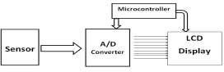

## What Is A 8051 Micíocontíolleí?

**Microcontrollers:** It is a programmable integrated circuit (IC) that consists of a small CPU, RAM and I/O pins. Microcontroller units (MCUs) are widely used in many devices.

**CPU:** It performs processing and is considered as the mind of the microcontroller. By giving instructions to the MCU, one can communicate with the I/O pins and control them as per needs.

**Memory:** It stores the instructions and data required by the microcontroller.

**Bus:** It acts as a communication medium between components for data transfer.

# 8051 Microcontroller

After the first 8051 microcontroller was designed by Intel in 1980, several powerful variants were made by adding ADCs, Op Amps and more. Along with these, the 8051 microcontroller had a 16-bit address bus for data transfer accompanied by an 8-bit data bus for carrying data for particular applications.

The current microcontroller belongs to the 8-bit family of microcontrollers and is packed with 128Kb of RAM, 4Kb of ROM, 4 ports, 2 timers and 1 serial port all on a single chip. These chips can easily be programmed using assembly language.

### Application

The 8051 MCUs are widely used in embedded systems, aeronautics, space technology, transportation management systems, robotics, communication, automotive and in many various fields.

These ICs can be used in a variety of embedded applications for [different](https://www.electronicsforu.com/electronics-projects/8051-microcontroller-projects-2) [projects](https://www.electronicsforu.com/electronics-projects/8051-microcontroller-projects-2) involving electronics and robotics.

* [Moving Message LCD Display](https://www.electronicsforu.com/electronics-projects/hardware-diy/moving-message-display-lcd)
* [Fuel Theft Alarm](https://www.electronicsforu.com/electronics-projects/anti-petrol-theft-alarm)
* [Water Level Indicator](https://www.electronicsforu.com/electronics-projects/hardware-diy/water-level-controller-cum-motor-protector)
* [RF Based Multipurpose Device](https://www.electronicsforu.com/electronics-projects/hardware-diy/microcontroller-rf-based-multiple-device-control)
* [Microcontroller-based Tachometer](https://www.electronicsforu.com/electronics-projects/hardware-diy/microcontroller-based-tach)
* [Microcontoller-based Tone ring player](https://www.electronicsforu.com/electronics-projects/hardware-diy/microcontroller-based-ring-tone-player)
* [Microcontroller-based Thermometer](https://www.electronicsforu.com/electronics-projects/hardware-diy/digital-thermometer-cum-controller-3)

# Pinouts and Functions of 8051 Microcontroller

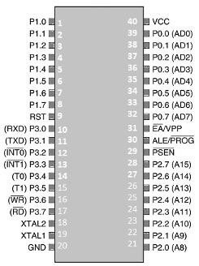

**Pins 1-8:** These are referred to as port 1 pins and are used for executing simple I/O operations. These pins can be configured by changing their logic state to 0 or 1.

**Pin 9:** This is known as the RESET pin for resetting the microcontroller. To terminate a running activity of the microcontroller, this pin can be used.

**Pin 10-17:** These are referred to as port 3 pins. Similar to port 1 pins, port 3 pins are used as universal input-output port along with executing a few more functions as described below:

**P3.0 (RXD):** This is a serial pin for receiving data. It is used for establishing serial communication to receive data through the input signal.

**P3.1 (TXD):** This is also a serial pin. It is used for data transmission through the output signal via the serial port.

**P3.2 and P3.3:** These pins are used for external hardware interrupts.

**P3.4 and P3.5 (T0 and T1):** These are timer pins that can be connected with a 16 bit counter.

**P3.6:** This is a memory write pin for writing data to external memory.

**P3.7:** This is an external memory read pin for reading the data from external memory.

**Pin 18 and 19:** These are the pins for external oscillators and can be connected to quartz oscillators to provide external clock frequency.

**Pin 20:** This is the ground (GND) pin for connecting the GND (negative) wire of sensors and modules used with the microcontroller.

**Pin 21 to 28:** These are referred to as port 2 pins. They are bidirectional and used for interfacing the external memory with the microcontroller

**Pin29:** This pin is known as Program Store Enable (PSEN). It is used for reading the external memory.

**Pin 30:** This pin is known as Address Latch Enable (ALE ). It is used for distinguishing the addresses of multiple memories.

**Pin 31:** This pin is known as External Input (External Access) input. It is used for enabling and disabling the external memory interfacing.

**Pin 32 – Pin 39:** These are port 0 pins. They are also bidirectional and used as an I/O port.

**Pin 40 (VCC):** It is a pin for supplying power to circuits with +5V.

**8051 Microcontroller Architecture:**

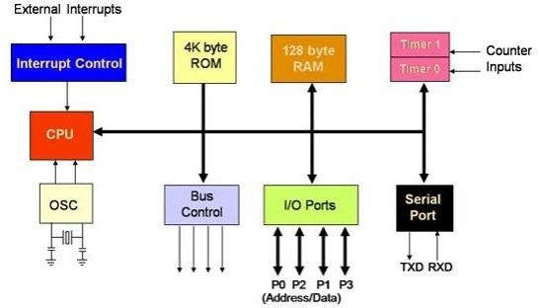

## Temperature Sensor (LM35)

The LM35 series are precision integrated-circuit temperature sensors, whose output voltage is linearly proportional to the Celsius (Centigrade) temperature. The LM35 thus has an advantage over linear temperature sensors calibrated in ˚ Kelvin, as the user is not required to subtract a large constant voltage from its output to obtain convenient Centigrade scaling. The LM35 does not require any external calibration or trimming to provide typical accuracies of ±1 ⁄4˚C at room temperature and ±3 ⁄4˚C over a full −55 to +150˚C temperature range. Low cost is assured by trimming and calibration at the wafer level. The LM35’s low output impedance, a linear output, and precise inherent calibration make interfacing to readout or control circuitry especially easy. It can be used with single power supplies, or with plus and minus supplies. As it draws only 60 µA from its supply, it has very low self-heating, less than 0.1˚C in still air. The LM35 is rated to operate over a −55˚ to +150˚C temperature range, while the LM35C is rated for a

−40˚ to +110˚C range (−10˚ with improved accuracy). The LM35 series is available packaged in hermetic TO-46 transistor packages, while the LM35C, LM35CA, and LM35D are also available in the plastic TO-92 transistor package. The LM35D is also available in an 8-lead surface to mount small outline package and a plastic TO-220 package.

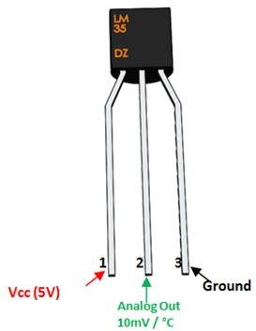

* + Calibrated directly in ˚ Celsius (Centigrade)
  + Linear + 10.0 mV/˚C scale factor
  + 0.5˚C accuracy guarantee able (at +25˚C)
  + Rated for full −55˚ to +150˚C range
  + Suitable for remote applications
  + Low cost due to wafer-level trimming
  + Operates from 4 to 30 volts
  + Less than 60 µA current drain
  + Low self-heating, 0.08˚C in still air
  + Nonlinearity only ±1 ⁄4˚C typical
  + Low impedance output, 0.1 Ω for 1 mA load

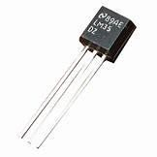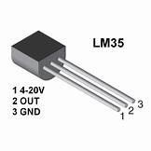

### ADC0804 interfacing with 8051

#### INTRODUCTION

Analog to digital converters find huge applications as an intermediate device to convert the signals from analog to digital form. These digital signals are used for further processing by the digital processors. Various sensors like temperature, pressure, force, etc. convert the physical characteristics into electrical signals that are analog in nature.

**WHY WE ARE USING ADC FOR THE MICROCONTROLLER?**

Well. 8051 doesn’t have an inbuilt ADC. So we have to use an external ADC. There are many ADCs available.

#### ADC 0804

The ADC0804 is a converter from analog to digital 8 bits. This ADC0804 has only one analog input channel with digital output of eight bits that can be 256 values of different measures. The step size is adjusted by setting the reference voltage in pin9 the reference input voltage can be adjusted to allow encoding any smaller range for the entire 8-bit resolution analog voltage. When the voltage reference pin is not connected to the ADC0804, the reference voltage defaults to the operating voltage, i.e, Vcc. The step size is 19.53mV 5V (5V

/ 255), i.e, for every increase of 19.53mV at the analog input, the output varies by 1 unit. To establish a determined voltage level as the reference value, this pin is connected to half the voltage. For example, to establish a reference 2V (Vref) is connected to 1V pin9 (Vref / 2), thereby reducing the step size to 7.84mV (2V / 255).

ADC0804 also needs a clock to operate. The conversion time of the analog value to a digital value depends on the clock source. An external clock can be given at the Clock IN pin. ADC 0804 also has an inbuilt clock that can be used in absence of an external clock. A suitable RC circuit is connected between the Clock IN and Clock R pins to use the internal clock.

### FEATURES

* 0V to 5V analog input voltage range with single 5V supply
* Compatible with microcontrollers, access time is 135 ns
* Easy interface to all microprocessors
* Logic inputs and outputs meet both MOS and TTL voltage level specifications
* Works with 2.5V (LM336) voltage reference
* On-chip clock generator
* No zero adjust required
* 0.3[Prime] standard width 20-pin DIP package
* Operates ratio metrically or with 5 VDC, 2.5 VDC, or analog span adjusted voltage reference
* Differential analog voltage inputs

### PIN DIAGRAM

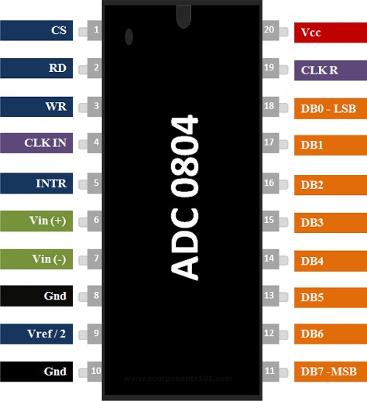

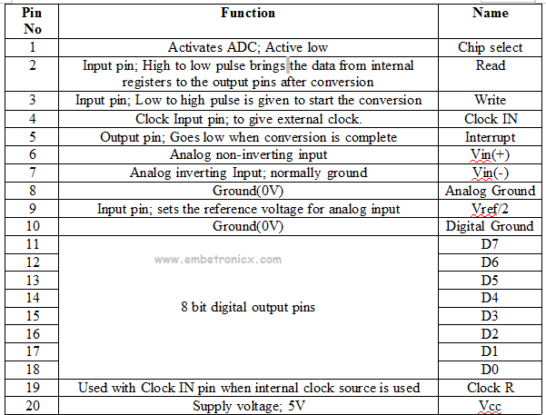**PIN DESCRIPTION**

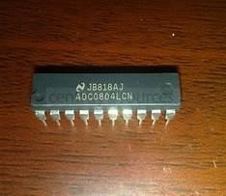

### HOW TO USE THE ADC0804?

* + Make Cs(chip select) low(0) to activate the ic. Here we are directly connecting that CS into Ground instead of connecting into 8051.
  + Make WR(write) pin low (0).
  + Make RD(read) pin high (1).
  + Make WR(write) pin high (1) after some delay small delay//This low to high impulse at WR pin starts your conversion.
  + Now check the INTR(interrupt) pin if it is high(1) conversion is running if it is low(0) the conversion is over.
  + Make RD=low(0) .
  + This will bring the converted value to the 8 data output pins of ADC 0804.

### ADC0804 interfacing with 8051

#### LCD: CALCULATION:

* + - RS: P0.5 Analog value=stepsize*Decimal value
    - RW: P0.6 stepsize=Vref/255
    - EN: P0.7 Vref=2.5V
    - Data Lines: P2 stepsize=2.5/255=10mV

#### ADC: Consider

* RD: P0.0
* WR: P0.1 Analog value=320mV
* INTR: P0.2 Digital value=320/10
* Output: P1 Digital value=32

**CIRCUIT DIAGRAM:**

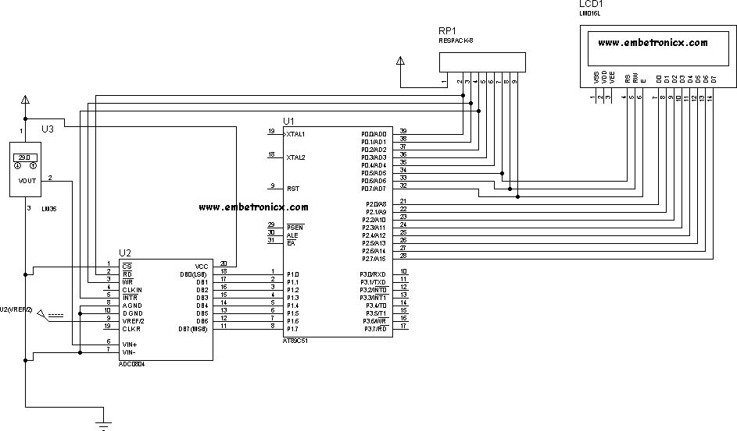

CIRCUIT DIAGRAM:

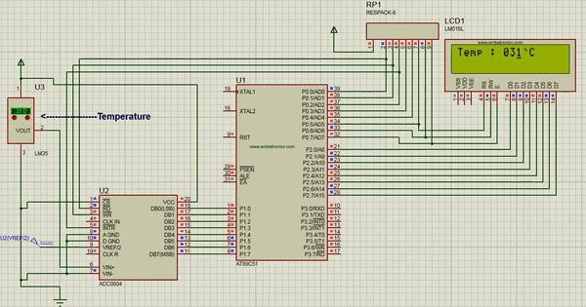



FLOWCHART:



INITIALIZE PORTS

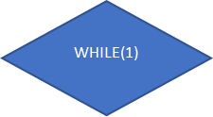

TRUE

FALSE

TRUE

#### CODE:

#include<reg51.h>

#define delay for(i=0;i<1000;i++); #define lcd P2

sbit rd=P0^0; sbit wr=P0^1; sbit intr=P0^2;

sbit rs=P0^5; sbit rw=P0^6; sbit en=P0^7;

void lcd_int();

void cmd(unsigned int b); void dat(unsigned int c); void show(unsigned char *s);

unsigned char adc(),get_value, conv; int i;

void main()

{

lcd_int(); show("Temp : "); while(1)

{

get_value = adc(); cmd(0x87); dat((get_value/100)+48);

dat(((get_value/10)%10)+48); dat((get_value%10)+48); dat(0x60);

dat('C');

}

}

void lcd_int()

{

cmd(0x38); cmd(0x0e);

cmd(0x06); cmd(0x01); cmd(0x80);

}

void cmd(unsigned int b)

{

lcd=b; rs=0; rw=0; en=1; delay; en=0;

}

void dat(unsigned int c)

{

lcd=c; rs=1; rw=0; en=1; delay; en=0;

}

void show(unsigned char *s)

{

while(*s) dat(*s++);

}

unsigned char adc()

{

wr=0; rd=1; wr=1;

while(intr==1); rd=0;

conv=P1; return conv;

}

#### CONCLUSION

* In our Project we used LM35 temperature sensor which gives varying voltage levels upon variations of temperature. These varying voltage levels are fed into the ADC and the digital output is fed into the microcontroller which is also programmed to display the corresponding temperature on the LCD. Thus we made a digital thermometer which is correct upto 0.5°C ranging from 0°C to 100°C which is capable enough to be used in practical day to day activities. Last, but not the least, the knowledge of the microcontroller has inspired us to portray our innovations and expand our thought process in new fields, which will be beneficial to human beings.